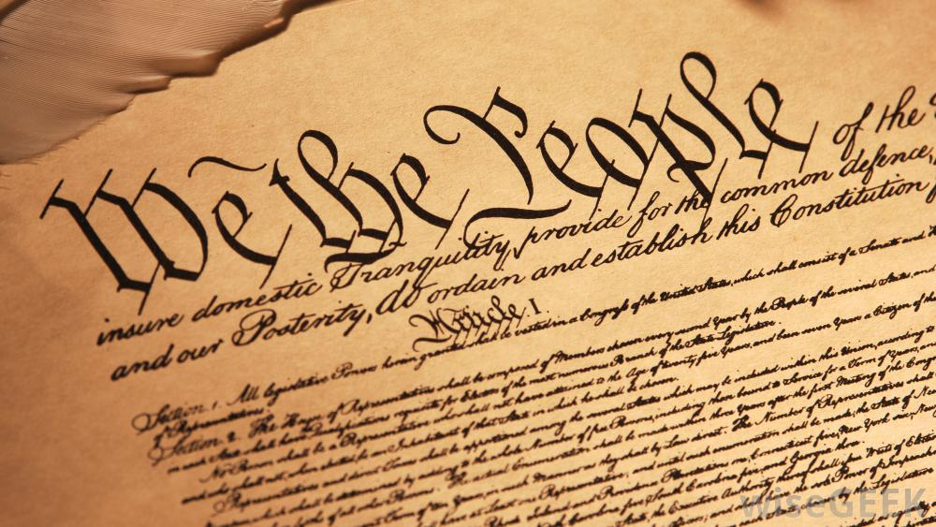
12th Grade - American Government Honors

Mrs. Jennifer Powell, Ed. S.
Lawton Chiles High School – Room 7205
powellj@leonschools.net
850-488-1756

“Let us never forget that government is ourselves and not an alien power over us. The ultimate rulers of our democracy are not a President and senators and congressmen and government officials, but the voters of this country.”
- President Franklin D. Roosevelt
Course Description: The purpose of this course is to give students a thorough understanding of the structure, function and processes of the United States government, the responsibilities and duties of citizenship and the role of the United States as a key player in a connected and interdependent world. The course outline below details the core components and major topics of study. Completing this course with a passing grade will fulfill the graduation requirement for government. Please remember: A passing grade is required in this course in order to receive your high school diploma.

Materials: 3 ring binder or folder, loose-leaf notebook paper; college or wide rule (no spiral paper), blue or black pens or pencil.

Textbook: United States Government: Our Democracy; McGraw-Hill

Course Outline:
Unit 1: Purpose of Government Unit 2: Foundations of Democracy Unit 3: The US Constitution
Unit 4: The Three Branches of Government Unit 5: The Political Process Unit 6: State & Local Government
Unit 7: Legal System Unit 8: Comparative Government

Sunshine State Standards: Available online at www.floridastandards.org/Standards/FLStandardSearch.aspx

Grading Scale: A=100-90 B=89-80 C=79-70 D=69-60 F=59-0

- Tests will be given at the conclusion of each units, which generally covers several chapters from the course text.
- Quizzes are generally conducted throughout each chapter studied and will cover vocabulary, notes or assigned readings. Pop quizzes can be given at any time.
- Homework will consist of question sets, developing vocabulary, reading passages, projects or worksheets. Course materials and handouts will be posted online. Students are responsible for obtaining the worksheets from the course website.

Semester Exam: All students will be required to take a semester exam. No exemptions are made for a semester course.

Film Permission: When pertinent, we may view clips from films or documentaries to supplement our learning. All films viewed in class will be rated G, PG, or PG-13. By signing and returning this slip, you are granting permission for your child’s supervised viewing of these supplementary videos for educational purposes.

Late Work: Homework will be turned in at the beginning of class. No late homework assignments will be accepted.

Class Expectations/Procedures
1. Students will come to class with all necessary supplies (see above.).
2. Students will not bring food, drink or gum into the classroom. Any student bringing food, drink or gum into the classroom will be asked to throw it away. Repeated violation of this rule will result in detention.
3. Students will not use cell phones, iPods, or other electronic devices in the classroom.
4. Students will be polite and respectful toward teacher and classmates. Students will raise their hands and wait to be recognized before speaking and will be respectful of opinions/views that differ from their own during class discussions and debates.
5. Students are expected to maintain their academic integrity and to work independently unless instructed differently by the teacher. If caught copying work, all students involved will receive zeros on the assignment. The Chiles Honor Code will be enforced.
6. This is an honors course and, as such, requires more effort, maturity, and focus. Work should be completed to the best of your ability and ON TIME. Late work will not be accepted.
7. Students will return all books and materials to their proper place before leaving class. Students are expected to leave their desk areas neat and free of trash.
8. Students are allowed 3 passes out of class per 9 weeks. (Can be used for restroom, retrieving forgotten materials, etc.)
9. The teacher, not the bell, dismisses class.

Tardy Policy: Students will be in their seats prepared to work when the bell rings.

1st Tardy – Warning 2nd Tardy – Parent Contact 3rd Tardy – Teacher Detention 4th Tardy – Referral

Any infraction of these expectations or procedures may result in disciplinary action.

Honors Courses: American government is a required course at Lawton Chiles High School but taking it at the Honors level is voluntary. Honors courses are intended to help prepare students for the rigors of college and are therefore more difficult and require more work. The extra effort put forth in Honors courses is shown to colleges by adding weight to the grade points earned in class towards a student’s overall grade point average (GPA). Students who volunteer to take an Honors course are volunteering to do the extra work and put forth the extra effort necessary to earn the added “weight” to their GPA.

Attendance/Make-up Policy
- Following an absence, the district policy will apply (1 day for every day absent) to determine how much time the student has to make-up the work and then submit it. It is the student’s responsibility to request make-up work after an absence.
- An absence before the day of a test or quiz that a student was informed of does not excuse them from the test or quiz.
- If a student misses a test, they will have one week to make up the test. After one week, there will be a percentage deduction for each additional week that the student takes to complete the test. Alternative versions of the test will be given.
- If a student misses a quiz, students will have one week to complete the quiz or they will receive a zero for that quiz. Once one week has passed from the day that the initial quiz was administered, students will not be able to make that quiz up.

Class Wish List: Any of the following items are super appreciated as they assist with class projects and keeping germs at bay. Thank you in advance for making our classroom environment productive and more enjoyable!

Kleenex, Glue Sticks, Highlighters, Colored Pencils, Markers, Hand sanitizer, Band-Aids, Ziploc bags, Colored or white copy paper

Please sign and return the attached document, acknowledging the course outline and your acceptance of the class rules, policies and procedures.

We have read and understand the expectations, policies and procedures specified for Mrs. Powell’s Honors American Government course.

_________________________________ _________________________________
Student Name (print) Student Signature ________ Period

__________________________________ _________________________________
Parent/Guardian Name (Print) Parent Signature

_____________________
Best Number to Reach Parent/Guardian

_____________________
Best Email to Reach Parent/Guardian

